12IT/A Website Evidence Document

Colours:

#??????

#??????

#??????

#??????

#??????

Viewport:

 <meta name="viewport" content="width=device-width, initial-scale=1.0">

# Implications

|  |  |  |
| --- | --- | --- |
| **Implication** | **How this relates to my project** | **How I have addressed this** |
|  |  |  |
|  |  |  |
|  |  |  |

# Testing Log

Explain fixes to design, validation etc based on your testing process.

|  |  |  |  |
| --- | --- | --- | --- |
|  | **Problems found: Chrome** | **Problems found:**  **Firefox** | **How these were fixed** |
| **Version 1 Testing** |  |  |  |
| **Version 2 Testing** |  |  |  |
| **Version 3 Testing** |  |  |  |

Testing Version 1:

There was an error with the validation of the <ul> as I had put the links as a direct child of this element

This was changed to

# Version 1

### Chrome Screenshot

### Microsoft Edge Screenshot

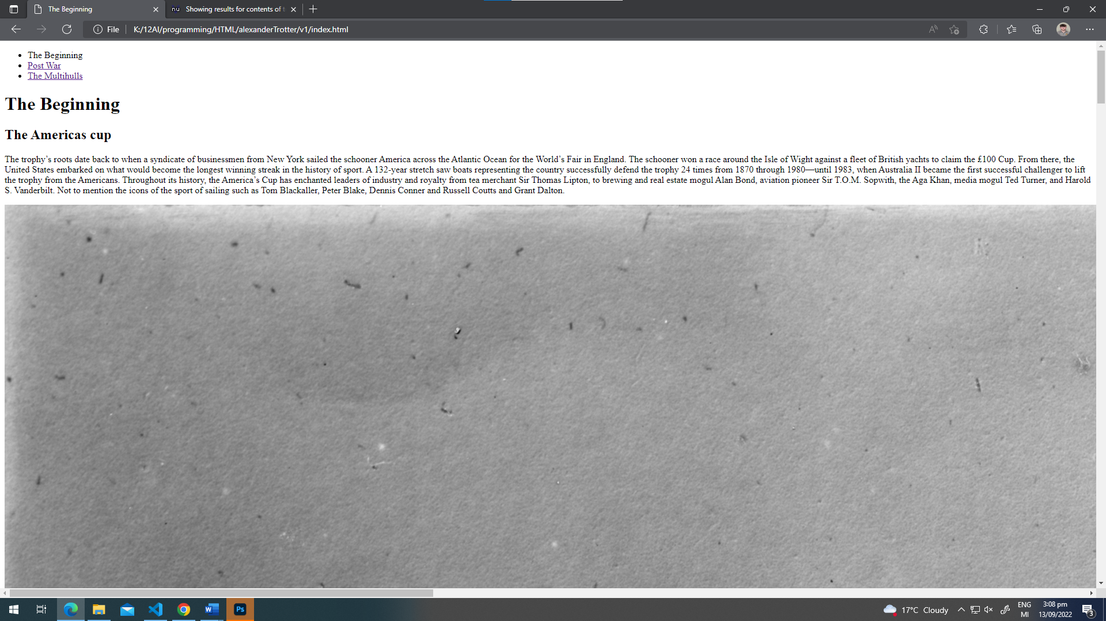

# Version 2

### Chrome Screenshot

### Microsoft Edge Screenshot

# Version 3

### Chrome Screenshot

### Microsoft Edge Screenshot

# Final Validation (Screenshots)

### Home

### Page 2

### Page 3

### CSS